INSTALL OPTION WORKING:

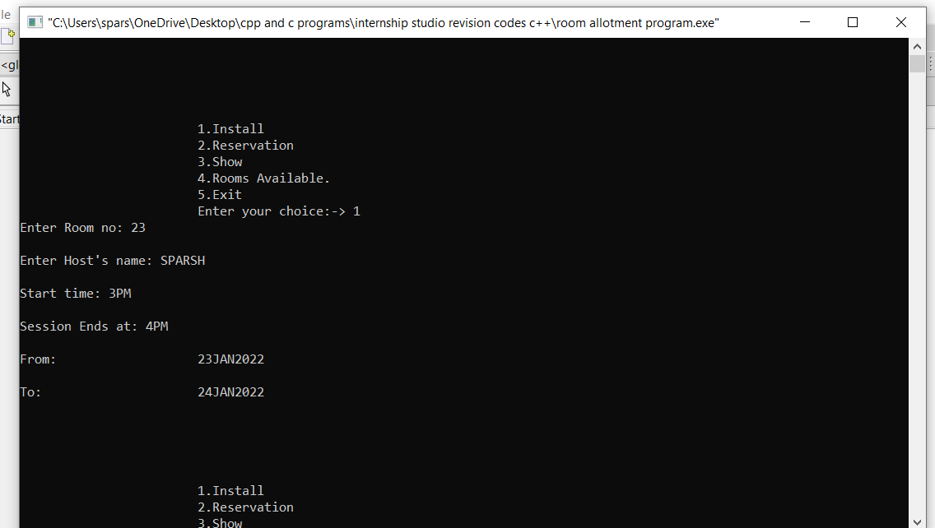

RESERVATION OPTION WORKING:

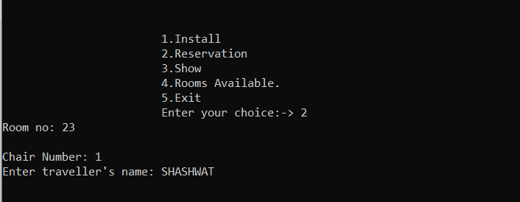

SHOW OPTION WORKING:

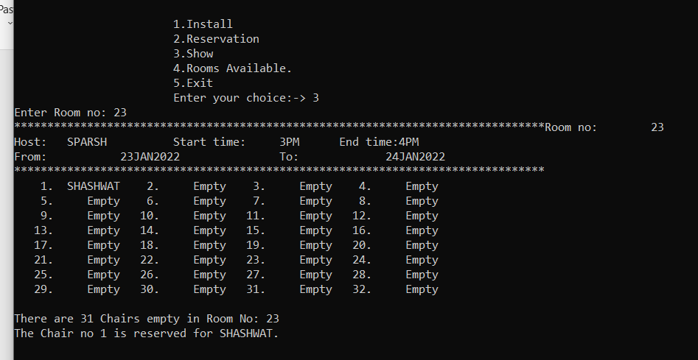

SHOW ROOMS AVAILABLE OPTION WORKING :

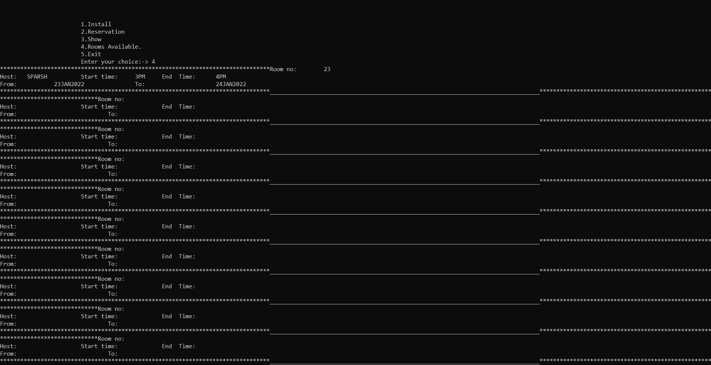

EXIT OPTION WORKING:

